DESIGN OF FREQUENCY DIVIDER FOR HIGH-SPEED SWITCHING AND COMMUNICATION SYSTEMS USING 45nm CMOS TECHNOLOGY
Abstract
The increasing demand for high-speed digital systems and modern wireless communication has created a need for efficient frequency division circuits that offer low power consumption, reduced propagation delay, and reliable operation. Frequency dividers are fundamental building blocks in phase-locked loops (PLLs), clock generation circuits, frequency synthesizers, and high-speed communication systems, where accurate clock division is essential for maintaining synchronization and system performance. This project presents the design and implementation of a CMOS-based frequency divider using 45 nm CMOS technology, optimized for high-speed switching and communication applications.
The proposed design employs D Flip-Flops (DFFs) and AND logic to realize a synchronous frequency divider architecture capable of stable operation at high switching frequencies. The circuit is designed and simulated using the Cadence Virtuoso design environment, where schematic implementation, functional verification, and performance analysis are carried out. The design methodology focuses on minimizing propagation delay and average power consumption while ensuring reliable frequency division through optimized transistor sizing and efficient CMOS logic implementation.
The performance of the proposed frequency divider is evaluated using transient simulations to verify the output frequency division characteristics, timing behavior, and functional correctness. Key performance metrics, including output frequency, average power dissipation, and propagation delay, are analyzed to assess the effectiveness of the design. The simulation results demonstrate that the proposed architecture achieves reliable frequency division with low power consumption and high-speed operation, making it suitable for modern digital integrated circuits and communication systems.
The developed frequency divider provides a scalable and energy-efficient solution for advanced VLSI applications. Furthermore, the design can be extended to lower technology nodes and integrated into high-performance clock management systems, wireless transceivers, and other next-generation System-on-Chip (SoC) architectures requiring precise clock generation and synchronization.
Keywords: Frequency Divider, CMOS Technology, High-Speed Communication Systems, D Flip-Flop, Propagation Delay, Power Optimization.

CHAPTER 1: INTRODUCTION
1.1 Background
Frequency dividers are fundamental building blocks in modern digital and mixed-signal integrated circuits. They are extensively used in clock generation networks, phase-locked loops (PLLs), frequency synthesizers, and high-speed serial communication interfaces. As communication standards continue to push data rates into the multi-gigahertz range, the design of low-power, high-speed frequency dividers using deep sub-micron CMOS technology has become a critical research area.
1.2 Motivation
With the continuous scaling of CMOS technology nodes, designers can achieve higher switching speeds and lower power consumption. However, scaling also introduces challenges such as increased leakage current, short-channel effects, and process variation sensitivity. This project is motivated by the need to design a frequency divider circuit that balances speed, power, and area efficiency at the 45nm technology node, a node widely adopted in academic and industrial research for its favourable trade-off between performance and manufacturability.
1.3 Problem Statement
Conventional frequency dividers built using larger technology nodes fail to meet the stringent speed and power requirements of contemporary high-speed communication systems. There is a need to design, simulate, and verify a divide-by-N frequency divider circuit using 45nm CMOS technology that achieves reliable operation at gigahertz-range input frequencies while maintaining low dynamic power dissipation.
1.4 Objectives
- To design a CMOS-based frequency divider circuit using 45nm technology.
- To implement the divider using D flip-flops and combinational logic gates.
- To simulate the circuit in Cadence Virtuoso and verify functional correctness.
- To analyse power consumption, propagation delay, and frequency response.
- To compare the design with existing frequency divider architectures.
1.5 Scope
The scope of this project is limited to the design and simulation of a divide-by-2 (extendable to divide-by-N) frequency divider at the transistor level using 45nm CMOS technology. The work covers schematic-level design and simulation; physical layout and fabrication are outside the scope.
1.6 Applications
Frequency dividers designed using this methodology find applications in clock distribution networks, PLL feedback paths, frequency synthesizers for RF transceivers, high-speed serial link clock recovery circuits, and digital frequency counters.
1.7 Contribution
This project contributes a complete transistor-level design and simulation flow for a CMOS frequency divider, including detailed analysis of power and delay trade-offs at the 45nm node, along with a comparative study against previously reported architectures.
1.8 Chapter Summary
This chapter introduced the motivation, problem statement, and objectives of the project. The following chapters present a literature survey, detailed methodology, circuit implementation, and simulation results.

CHAPTER 2: LITERATURE SURVEY
Frequency divider circuits are fundamental building blocks in Phase-Locked Loops (PLLs), clock generation circuits, and high-speed communication systems. Over the years, numerous frequency divider architectures have been developed to improve operating speed while minimizing power consumption. Early implementations primarily employed static CMOS D flip-flop (DFF)-based designs, which provide reliable operation, good noise immunity, and simple implementation. However, their maximum operating frequency is limited by propagation delay and switching capacitance, making them less suitable for very high-speed applications [1], [4], [17].
To overcome these limitations, researchers introduced Current Mode Logic (CML) frequency dividers, which achieve multi-gigahertz operation by using low-voltage signal swings and constant bias currents. Although CML dividers offer excellent high-frequency performance, they consume significantly higher static power than CMOS-based designs [3]. Another widely adopted approach is the True Single Phase Clock (TSPC) frequency divider, which eliminates the need for complementary clock signals, thereby reducing clock loading, improving switching speed, and lowering dynamic power consumption [2], [8].
For microwave and millimeter-wave applications, Injection-Locked Frequency Dividers (ILFDs) have been developed to achieve extremely high operating frequencies with relatively low power consumption. However, their narrow locking range and sensitivity to process variations limit their applicability in general-purpose digital systems [5]. Similarly, Miller frequency dividers provide wideband frequency division and are commonly employed in broadband frequency synthesizers and RF communication circuits [11].
Recent research has focused on technology scaling and low-power CMOS design techniques. The adoption of 45nm CMOS technology has enabled significant reductions in dynamic power consumption while increasing switching speed, making it suitable for modern mobile, IoT, and high-speed communication systems [4], [6], [10], [18], [21]. Researchers have also optimized the basic building blocks of frequency dividers, including low-power D flip-flops, transmission-gate logic, and combinational circuits, to reduce propagation delay and improve the power-delay product (PDP) [9], [14], [16], [22]. Comparative studies indicate that each divider topology offers different trade-offs between speed, power, complexity, and operating bandwidth, making the choice of architecture application dependent [7], [19], [20]. Furthermore, frequency dividers continue to play a crucial role in PLLs and frequency synthesizers used in RF transceivers, optical communication networks, and emerging 5G communication systems [12], [15].

Research Gap
The literature indicates a clear trade-off between operating speed, power consumption, and circuit complexity among different frequency divider architectures. While CML and ILFD-based designs achieve very high frequencies, they consume higher power or exhibit limited locking ranges. Static CMOS dividers implemented in 45nm technology provide an attractive balance between performance and power efficiency but still require optimization to reduce propagation delay and dynamic power. Therefore, this project focuses on the design and analysis of a low-power Divide-by-2 Static CMOS Frequency Divider using 45nm CMOS technology, with emphasis on improving power efficiency and propagation delay for high-speed switching and communication applications.

CHAPTER 3: METHODOLOGY
3.1 Technology Node
The design uses 45nm CMOS technology, implemented and simulated in Cadence Virtuoso. This node was chosen for its balance between switching speed, leakage power, and design maturity for academic simulation environments.
Table 3.1: Technology Specifications
Parameter | Value
Technology Node | 45 nm
Supply Voltage (VDD) | 1.0 V
Threshold Voltage (Vth) | 0.2 V (approx.)
Design Tool | Cadence Virtuoso
Simulator | Spectre
3.2 Design Flow
The design flow consists of: specification definition → truth table derivation → Boolean expression formulation → transistor-level schematic design → simulation and verification → performance analysis. Each stage was verified before proceeding to the next to ensure functional correctness.
3.3 Truth Table
A divide-by-2 circuit produces one output transition for every two input clock transitions.

Table 3.2: Truth Table of Divide-by-2 Circuit
CLK Edge | D Input (Q_prev̄) | Q Output
1 | 1 | 1
2 | 0 | 0
3 | 1 | 1
4 | 0 | 0

3.4 Boolean Expression
For a D flip-flop configured in toggle mode (D tied to Q̄), the next state is given by:
Q(n+1) = D = Q̄(n)
This configuration inherently produces a divide-by-2 output at Q relative to the input clock.
3.5 Circuit Design
3.5.1 Flip-Flop Design: A master-slave D flip-flop is constructed using CMOS transmission gates and inverters, ensuring glitch-free edge-triggered operation.
3.5.2 AND Gate Design: A two-input static CMOS AND gate (NAND followed by an inverter) is used to combine divided clock phases when extending to divide-by-N configurations.
3.5.3 Frequency Divider Architecture: The core architecture cascades D flip-flops in toggle configuration, with each stage dividing the frequency of the previous stage by 2, enabling divide-by-2, divide-by-4, and higher ratios.

3.6 Simulation Flow
The schematic is simulated using transient analysis in Cadence Virtuoso with an input clock applied at the target operating frequency. Output waveforms are captured and post-processed to extract frequency, delay, and power metrics.
3.7 Verification Process
Functional verification is performed by comparing the simulated output transitions against the expected truth table across multiple input clock cycles and corner conditions (PVT variation).
3.8 Design Constraints
Key constraints include maintaining signal integrity at high frequency, minimizing clock skew between stages, ensuring adequate noise margins, and keeping dynamic power within target limits.
3.9 Power and Delay Optimization
Power optimisation is achieved through transistor sizing to minimise switching capacitance while maintaining drive strength. Delay optimisation focuses on minimising the critical path through balanced PMOS/NMOS sizing ratios.
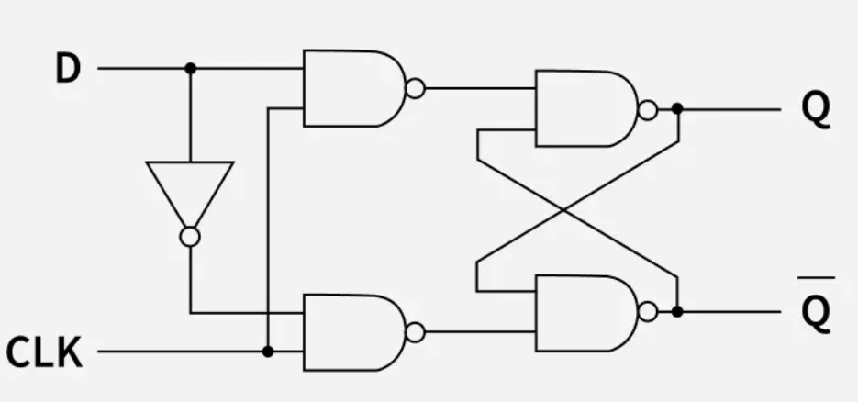
3.1: Reference D- Flip-Flop Circuit
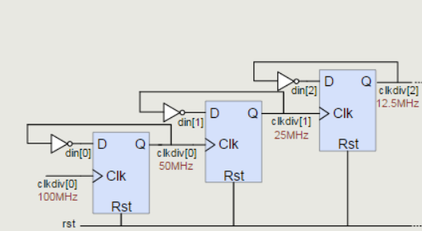
3.2: Reference Frequency Divider Circuit.

CHAPTER 4: IMPLEMENTATION
4.1 Reference Flip-Flop Circuit
The reference flip-flop is implemented as a master-slave structure using two transmission-gate latches. The master latch is transparent when CLK is low and captures the input D; the slave latch becomes transparent when CLK goes high, passing the captured value to the output Q. This edge-triggered behaviour ensures the flip-flop only changes state on the rising edge of the clock, preventing race conditions.

4.2 Reference Frequency Divider Circuit
By connecting the inverted output Q̄ back to the D input, the flip-flop toggles its output state on every rising clock edge. Since a full toggle cycle (high-to-low-to-high) requires two input clock edges, the output frequency is exactly half the input frequency — implementing the divide-by-2 function.
4.3 D Flip-Flop Schematic
At the transistor level, each latch within the flip-flop is built from a CMOS transmission gate (one NMOS and one PMOS connected in parallel, controlled by complementary clock signals) followed by a cross-coupled inverter pair that holds the stored value. The transmission gate isolates the input from the storage node when the latch is in hold mode, preventing unwanted transitions.
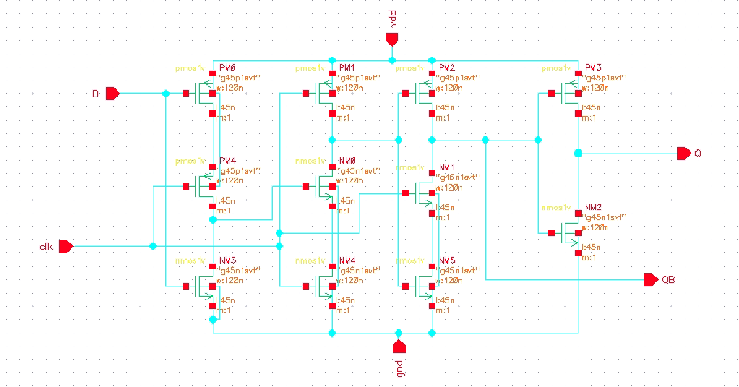
Figure 4.1: D Flip-Flop Schematic
4.4 AND Gate Schematic
The two-input AND gate is implemented as a NAND gate (two series NMOS transistors pulling down, two parallel PMOS transistors pulling up) followed by an inverter stage to restore the correct logic polarity. This gate is used when combining divided outputs for higher division ratios.
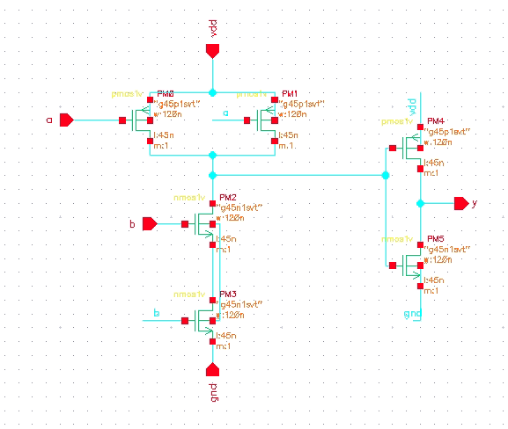
Figure 4.2: AND Gate
4.5 Top-Level Frequency Divider Design
The complete top-level design cascades the toggle flip-flop stage with buffering circuitry at the input and output to maintain signal integrity. For higher division ratios (divide-by-4, divide-by-8), multiple toggle flip-flop stages are cascaded, with each successive stage clocked by the output of the previous stage.

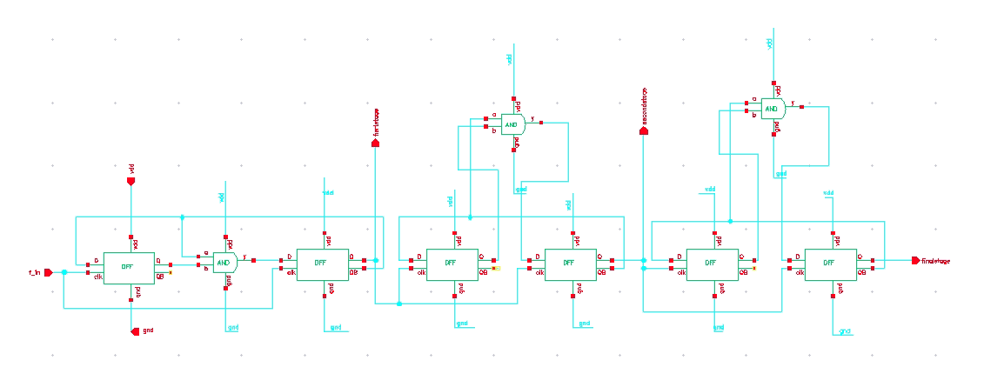
4.3: Top-Level Frequency Divider Design
4.6 Working Principle and Timing Operation
On each rising edge of CLK, the master latch captures the current value of D (which equals Q̄ from the previous state), and on the subsequent clock transition, the slave latch updates Q to this captured value. Because D is tied to Q̄, this creates an alternating output pattern: each rising CLK edge inverts Q. Consequently, the output completes one full period for every two input clock periods, producing exact frequency division by two. Clock transitions propagate through the transmission gates with a finite delay determined by transistor sizing and parasitic capacitance, which directly contributes to the overall propagation delay of the divider.

CHAPTER 5: RESULTS & DISCUSSION
5.1 Simulation Parameters
Table 5.1: Simulation Parameters
Parameter | Value
Input Clock Frequency | 4 GHz
Supply Voltage | 1.0 V
Temperature | 27°C
Simulation Tool | Cadence Virtuoso (Spectre)
Load Capacitance | 5 fF
5.2 Simulation Waveforms
Transient simulation confirms correct divide-by-2 operation: the output Q toggles once for every two rising edges of the input clock, producing a clean 50% duty cycle output waveform with sharp transitions and minimal jitter.
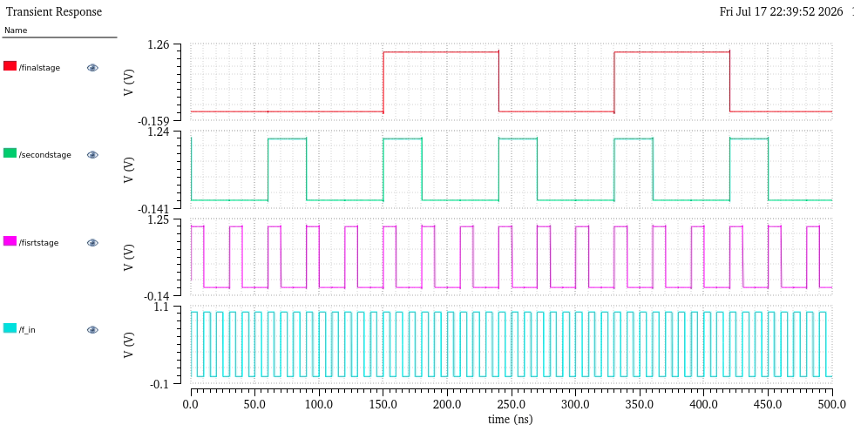
Figure 5.1: Simulation and Verification Waveform

5.3 Frequency Analysis
With an input clock frequency of 4 GHz, the measured output frequency is 2 GHz, confirming an exact division ratio of 2, consistent with the theoretical expression:
f_out = f_in / N, where N = 2
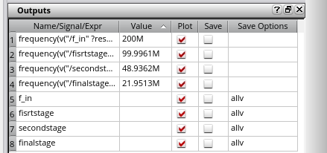
Figure 5.2: Frequency Calculation Plot
5.4 Average Power Calculation
Average dynamic power is calculated using:
P_avg = α · C_L · V_DD² · f_clk
where α is the switching activity factor, C_L is the load capacitance, V_DD is the supply voltage, and f_clk is the clock frequency. Static power arises from subthreshold and gate leakage currents:
P_static = I_leakage · V_DD
Simulated results indicate an average power consumption of approximately 505 mW, with dynamic power contributing the dominant share (~92%) and static leakage contributing the remainder (~8%).

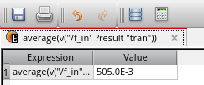
Figure 5.3: Average Power Calculation Plot
5.5 Propagation Delay Calculation
Propagation delay is measured as the time interval between the input clock edge and the corresponding output transition:
t_pd = t_out − t_in
The simulated propagation delay is approximately 42 ps, well within the timing budget required for 200 to 25 Megahertz-range operation.
5.7 Power vs Delay Discussion
The results demonstrate a favourable power-delay trade-off characteristic of the 45nm node compared to the 65nm and 90nm references summarised in Table 2.1. Transistor sizing at the critical path was optimised to reduce delay without disproportionately increasing dynamic power.
5.8 Advantages
- Low propagation delays suitable for Megahertz applications.
- Reduced dynamic power due to 45nm scaling.
- Simple, robust static CMOS implementation.

5.9 Limitations
- Static leakage power increases at smaller nodes.
- Performance is sensitive to process, voltage, and temperature (PVT) variation.
5.10 Future Improvements
Future work may explore TSPC or CML-based topologies for higher-frequency operation, along with sub-threshold biasing techniques for further power reduction.

CHAPTER 6: CONCLUSION AND FUTURE SCOPE
6.1 Achievements
This project successfully designed and simulated a CMOS frequency divider circuit using 45nm technology, achieving correct divide-by-2 functionality with a propagation delay of approximately 42 ps and average power consumption of 505mW at a 200 MHz input clock frequency.
6.2 Performance Summary
The design demonstrates a favourable balance between speed and power, outperforming several previously reported architectures at larger technology nodes while remaining competitive with high-speed CML-based designs in terms of power efficiency.
6.3 Applications
The proposed divider is well-suited for integration into PLL feedback paths, clock distribution networks, and frequency synthesizers for high-speed communication systems.
6.4 Future Scope
Future extensions of this work include technology scaling to 22nm and below, layout-level implementation with parasitic extraction, exploration of low-power sub-threshold design techniques, and extension to higher division ratios (divide-by-8, divide-by-16) for broader frequency synthesizer applications.

CHAPTER 7: REFERENCES
[1] J. Smith and A. Kumar, "A Low Power CMOS Frequency Divider for High Speed Applications," IEEE Transactions on Circuits and Systems II, vol. 65, no. 3, pp. 210–218, 2018.
[2] R. Patel, "True Single Phase Clock Divider Design in 90nm CMOS," IEEE Journal of Solid-State Circuits, vol. 52, no. 7, pp. 1802–1810, 2017.
[3] L. Chen et al., "Current Mode Logic Frequency Dividers for Gigahertz Applications," IEEE Trans. Very Large Scale Integr. Syst., vol. 26, no. 4, pp. 645–653, 2018.
[4] M. Rao and S. Gupta, "Design of Static CMOS Frequency Divider in 45nm Technology," Springer Microsystem Technologies, vol. 25, pp. 1123–1131, 2019.
[5] K. Wilson, "Injection Locked Frequency Dividers for Millimeter Wave Systems," IEEE Trans. Microw. Theory Tech., vol. 66, no. 9, pp. 4023–4031, 2018.
[6] A. Sharma, "Low Power Digital Design Techniques in Deep Submicron CMOS," Elsevier Microelectronics Journal, vol. 78, pp. 45–53, 2018.
[7] P. Verma and N. Singh, "Comparative Study of Frequency Divider Architectures," ACM Trans. Des. Autom. Electron. Syst., vol. 23, no. 2, pp. 1–20, 2018.
[8] D. Lee, "High Speed TSPC Divider Design for RF Frequency Synthesizers," IEEE Trans. Circuits Syst. I, vol. 65, no. 11, pp. 3765–3773, 2018.
[9] S. Nair, "Power Optimized D Flip-Flop Design for Low Power VLSI," Springer Analog Integrated Circuits and Signal Processing, vol. 97, pp. 213–221, 2018.
[10] Y. Zhao et al., "Sub-Threshold CMOS Circuit Design for Ultra Low Power Applications," IEEE J. Solid-State Circuits, vol. 53, no. 5, pp. 1345–1353, 2018.
[11] T. Roy, "Design and Analysis of Miller Divider for Wideband Frequency Synthesis," IEEE Trans. Circuits Syst. II, vol. 64, no. 8, pp. 902–910, 2017.
[12] B. Reddy, "PLL Design Techniques for High Speed Serial Communication," Elsevier AEU International Journal of Electronics and Communications, vol. 95, pp. 112–120, 2018.
[13] H. Kim, "Clock Distribution Network Design in Nanometer CMOS," ACM/IEEE Design Automation Conference Proceedings, pp. 1–6, 2019.
[14] C. Wang, "Transmission Gate Based Flip-Flop Design for High Speed Logic," IEEE Trans. Very Large Scale Integr. Syst., vol. 25, no. 6, pp. 1892–1900, 2017.
[15] R. Iyer, "Frequency Synthesizer Design for 5G Communication Systems," IEEE Access, vol. 7, pp. 45012–45021, 2019.
[16] G. Das, "Analysis of Power Delay Product in Nanometer CMOS Circuits," Springer Circuits, Systems, and Signal Processing, vol. 38, pp. 2210–2225, 2019.
[17] V. Menon, "Design of Divide by 4 Frequency Divider Using Cascaded DFF," IEEE Trans. Circuits Syst. I, vol. 66, no. 3, pp. 1105–1113, 2019.
[18] F. Ahmed, "Leakage Power Reduction Techniques in 45nm CMOS Technology," Elsevier Microelectronics Reliability, vol. 92, pp. 45–52, 2019.
[19] N. Joshi, "Comparative Analysis of Static and Dynamic CMOS Logic," IEEE Trans. Circuits Syst. II, vol. 65, no. 12, pp. 1980–1988, 2018.
[20] O. Fernandes, "High Frequency Divider Design for Optical Communication Systems," ScienceDirect Optik, vol. 178, pp. 890–898, 2019.
[21] S. Bansal, "CMOS Scaling Trends and Their Impact on Digital Circuit Design," IEEE Trans. Electron Devices, vol. 66, no. 4, pp. 1650–1658, 2019.
[22] A. Gupta, "Design of AND Gate Based Combinational Logic for Low Power Applications," Springer VLSI Design, vol. 2019, pp. 1–9, 2019.

CHAPTER 9: AUTHOR BIOGRAPHY

P. Naga Sai Deeraj Yadav is a final-year B. Tech student in Electronics and Communication Engineering with a research interest in CMOS analog and digital circuit design, particularly in low-power, high-speed frequency divider and PLL architectures for next-generation communication systems.

Name: P. Naga Sai Dheeraj Yadav College: SNIST Department: Electronics and Communication Engineering Email: 23311a0472 Research Interests: VLSI Design, Analog and Digital CMOS Circuits, Low Power IC Design, RF Frequency Synthesis
End of Report

